A PROJECT REPORT ON:

ANALOG LINE-FOLLOWER ROBOT

ABSTRACT
This report details the design and implementation of a Line-Follower Robot (LFR) utilizing a purely analog control system. The primary objective is to engineer a vehicle capable of navigating a black track on a white surface using Infrared (IR) sensors, an LM358 operational amplifier for signal processing, and an L293D motor driver used to control the motors(wheels). The system is designed to meet the specific requirements of the EEG 331 project and design competition, which mandates autonomous tracking across line widths of 20mm, 15mm, and 10mm. The design focuses on hardware-level calibration through the tuning of potentiometers to set optimal threshold voltages for different lighting surfaces(reflective or absorbing).

1.0 INTRODUCTION
Autonomous navigation systems represent a cornerstone of modern industrial automation, bridging the gap between static machinery and mobile intelligence. This project details the design and implementation a robotic platform capable of navigating a predefined path using a purely analog control architecture. In the context of modern smart-logistics pioneered by global leaders such as Amazon and Tesla AGVs facilitate the seamless movement of goods with high spatial efficiency and minimal human intervention. Mastering the principles of analog tracking systems is essential for electrical engineers, as these hardware-based solutions provide real-time responsiveness without the computational overhead or latency associated with digital microprocessors.

2.0 OBJECTIVES
The main goals of this design project are as follows:
Design and Construction: To design, build, and test a robot capable of autonomously following a predefined line using infrared (IR) sensors and analog circuits.
Analog Integration: To successfully integrate sensing, decision-making, and actuation into a functional system without the use of a microcontroller.
Performance Reliability: To ensure the robot can follow lines of varying thicknesses during the competition rounds:
- Round 1: 20mm standard line.
- Round 2: 15mm challenge line.
- Final Round: 10mm precision line.
Optimization: To maximize the robot's performance based on the specific scoring criteria:
- Tracking Accuracy (50%): How well the robot stays centered on the line.
- Completion Speed (30%): How fast the robot finishes the track.
- Recovery (20%): How effectively the robot returns to the path after a deviation.

3.0 SYSTEM DESIGN
IR SENSORS DETECT SURFACE(REFLECTIVE OR ABSORBTIVE)
COMPARATOR(LM358)
Outputs high/low control signal based o Vsensor
Vs Vred threshold
MOTOR driver(l293d)
Drives the motors based on LM358 logic signals from lm358
DC motors
Receives current from the L293D to drive the wheels.s

3.1. System Components
- Sensing (Input): 2 Pairs of emitters and receivers
- Processing (Control): LM358 Dual Op-Amp acting as comparators. Thresholds are set via 10kΩ Potentiometers.
- Actuation (Output): L293D Motor Driver controls the two DC geared motors.
- Regulation:5v regulator providing a stabilized 5V supply to the logic circuit.

3.2. INITIAL CIRCUIT DESIGN
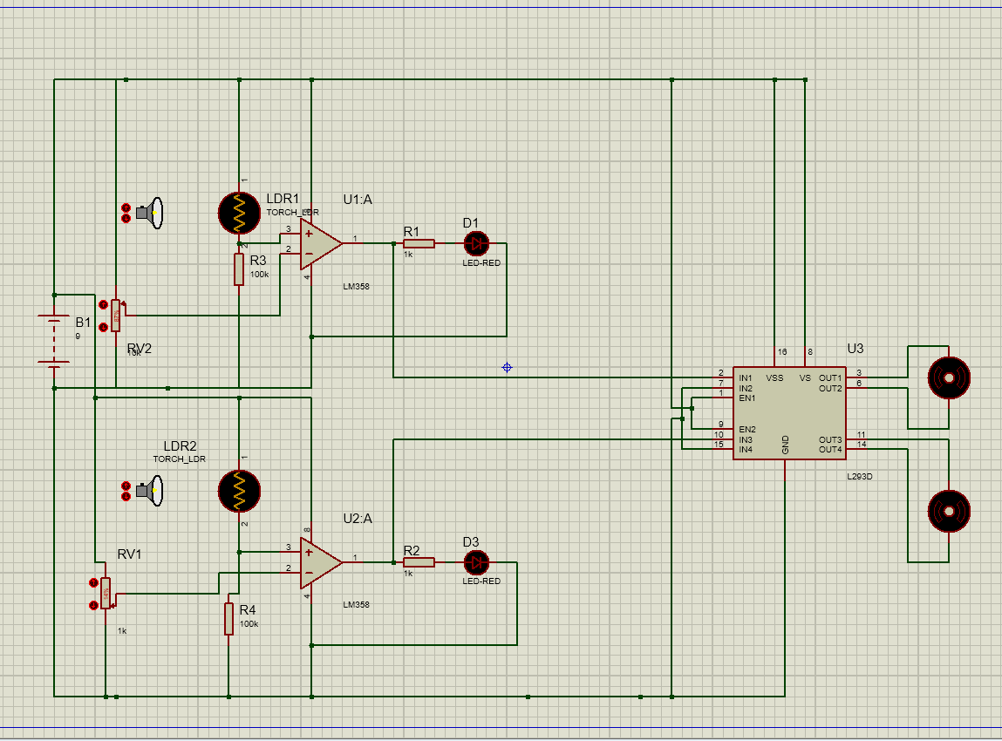

System Power and Track Sensing
The line-following robot operates on a deterministic control logic achieved by integrating an analog sensor array, a comparator circuit, and a high-current motor driver. The track sensing is handled by two independent voltage dividers, each consisting of an Infrared (IR) transmitter and receiver (modeled in the initial simulation as Light Dependent Resistors). The IR LED continuously emits light toward the track. When the sensor is positioned over a highly reflective white surface, the transmitted IR rays bounce back into the receiver. This drastically drops the receiver's internal resistance, pulling the analog voltage at the non-inverting input (Pin 3) of the LM358 comparator high. Conversely, when the sensor passes over an absorptive black line, the lack of reflected light keeps the receiver's resistance high, pulling the voltage at Pin 3 toward ground.
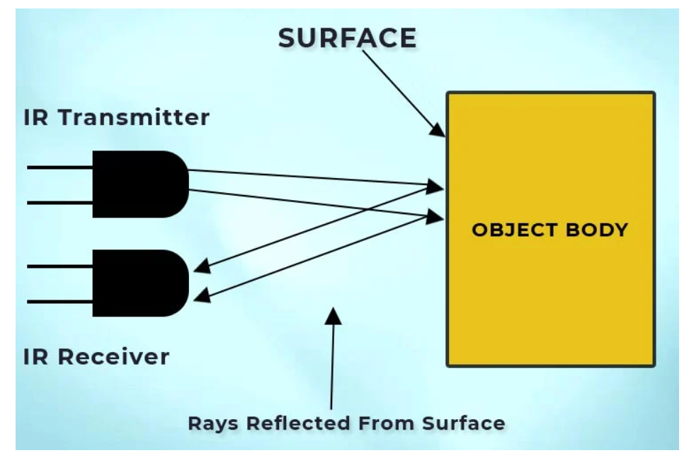

Threshold Logic and Signal Comparison
The decision-making core of the robot relies on the LM358 operational amplifier(dual op amp) functioning as a voltage comparator. To determine the exact cutoff point between the "white background" and the "black line," 10k potentiometers are used to create a tunable reference voltage at the inverting input (Pin 2). The LM358 continuously compares the fluctuating analog sensor voltage at Pin 3 against this fixed threshold. If the sensor voltage is higher than the reference (indicating a white surface), the comparator gives a HIGH output. If the sensor voltage drops below the threshold (indicating the black line), the output switches to LOW. Red LEDs are attached to these output lines to serve as immediate visual indicators, allowing for real-time physical calibration of the potentiometers.
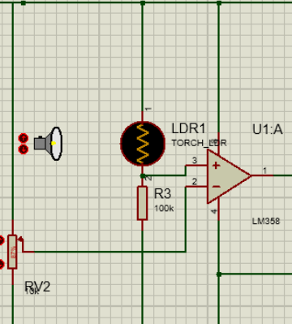

Motor Actuation and Differential Steering
The low-current logic signals produced by the LM358 are fed into an L293D dual H-bridge motor driver to handle the physical actuation. The L293D is essential because it can control the speed and direction of the motors based on the input logic, acting as a high-power switch that the op-amps alone cannot provide. With the driver's enable pins wired directly HIGH, a HIGH signal from the LM358 triggers the L293D to route main battery power to the corresponding motor. Therefore, when a sensor is on the white background, its motor drives forward. If a sensor hits the black line, its comparator outputs a LOW signal, stopping that specific motor. This natively creates differential steering: stopping one motor while the other continues pushing causes the robot's chassis to pivot sharply back toward the center of the track.

Real-World Implementation and Power Regulation Revision
Initially, the system was modeled to run entirely in parallel off a standard 9V battery source. While this unregulated parallel configuration works flawlessly in a software simulation, transitioning to a physical prototype revealed critical hardware constraints that necessitated the addition of a 5V linear voltage regulator.
According to the L293D datasheet, while the motor supply pin Vs can safely handle the 9V battery, the internal logic supply pin ($V_{SS}$) has a strict absolute maximum rating of 7V. Feeding an unregulated 9V directly into the logic rail risks permanently damaging the IC. Furthermore, powering the sensor voltage dividers and LM358 reference pins directly from the main battery introduces severe analog instability. As the DC motors draw heavy current to turn the wheels, the battery experiences "voltage droop." If the comparator's reference voltage is tied to this fluctuating supply, the threshold between the line and the background will constantly drift, resulting in erratic steering. Because of these things we had to revise the circuit design.
REVISED CIRCUIT DESIGN:

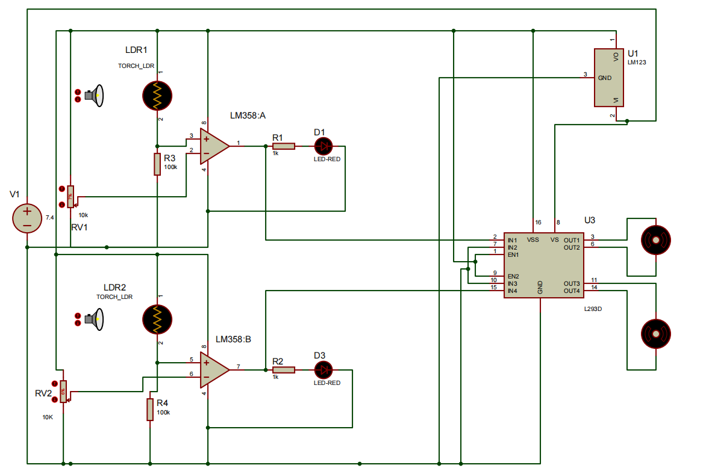

By integrating a 5V regulator,with a 7.4 v power supply(3.7v batteries in series), the heavy-duty motor power is completely isolated from the sensitive logic control. This revision ensures the L293D operates safely within its datasheet limits while providing a rock-solid, deterministic 5V reference for the analog sensors, which is critical for maintaining accuracy on the 10mm precision competition track.

4.0 CALCULATIONS AND ENGINEERING DESIGN
The LM358 comparator's logic relies on comparing two completely independent voltage dividers: a dynamic sensor divider and a tunable reference divider. Both are powered by the regulated 5V logic rail to ensure stability.

4.1. The Sensor Voltage Divider (Non-Inverting Input, Pin 3)
This side of the circuit translates physical light intensity into a dynamic analog voltage $(V_{sensor}).$
It consists of an IR receiver (modeled as an LDR in our simulation) and a strictly fixed 100 kΩ pull-down resistor. The 100 kΩ resistor must remain fixed so that ambient light is the only variable altering the voltage.
Assuming a regulated 5V supply and a fixed resistor of 100 kΩ:
$V_{sensor}=V_{cc}×\left(\frac{R_{fixed}}{R_{LDR}+R_{fixed}}\right)$
On a White Surface (Reflective): The receiver receives high IR reflection, dropping its resistance $(R_{LDR}$) to approximately 10 kΩ.
$V_{sensor}=5×\left(\frac{100,000}{10,000+100,000}\right)≈4.54V$
Black Line (Absorptive): The receiver receives minimal IR reflection, raising its resistance to approximately 500 kΩ.
$V_{sensor}=5×\left(\frac{100,000}{500,000+100,000}\right)≈0.83V$

4.2. The Reference Voltage Divider (Inverting Input, Pin 2)
This side of the circuit provides the static threshold voltage $(V_{ref})$ that the sensor voltage is compared against. It consists entirely of a single 10 kΩ potentiometer. The potentiometer acts as an adjustable voltage divider, allowing the user to manually tune the threshold to account for different room lighting conditions.
To achieve the highest noise immunity, the reference voltage must be tuned to the exact midpoint of the sensor's voltage swing calculated above:
$V_{ref}=\frac{V_{white}+V_{black}}{2}$
$V_{ref}=\frac{4.54+0.83}{2}≈2.68V$
To calculate the physical position of the 10 kΩ potentiometer required to output this 2.68V threshold, we calculate the resistance needed at the lower half of the potentiometer wiper $(R_{bottom})$:
$V_{ref}=V_{cc}×\left(\frac{R_{bottom}}{R_{total}}\right)2.68$
$=5×\left(\frac{R_{bottom}}{10,000}\right)R_{bottom}$
$=10,000×\left(\frac{2.68}{5}\right)=5,360Ω$
$Dial Position=\left(\frac{5,360}{10,000}\right)×100=53.6\%$
Calibration Conclusion: The 10 kΩ potentiometer dial must be turned to approximately 53.6% of its rotation to provide the optimal 2.68V switching threshold.

4.3. Comparator Logic Integration
With both dividers established, the LM358 operational amplifier simply evaluates the two nodes.
If the robot is over the white track,$V_{sensor}$ (4.54V) is greater than $V_{ref}$ (2.68V), causing the comparator to output a HIGH signal to drive the motor.
If the robot crosses the black line, $V_{sensor}$ (0.83V) drops below $V_{ref}$ (2.68V), causing the comparator to output a LOW signal to stop the motor and correct the steering.

5.0 SIMULATION AND RESULTS

5.1. Software Simulation
The logic was validated via Proteus and Tinkercad simulation to ensure the LM358 correctly toggled the L293D inputs based on varying 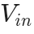 levels.

5.2. Hardware Implementation
The physical prototype was assembled on an acrylic chassis. The sensor array was fixed at a 12mm spacing to maintain cross-round compatibility.

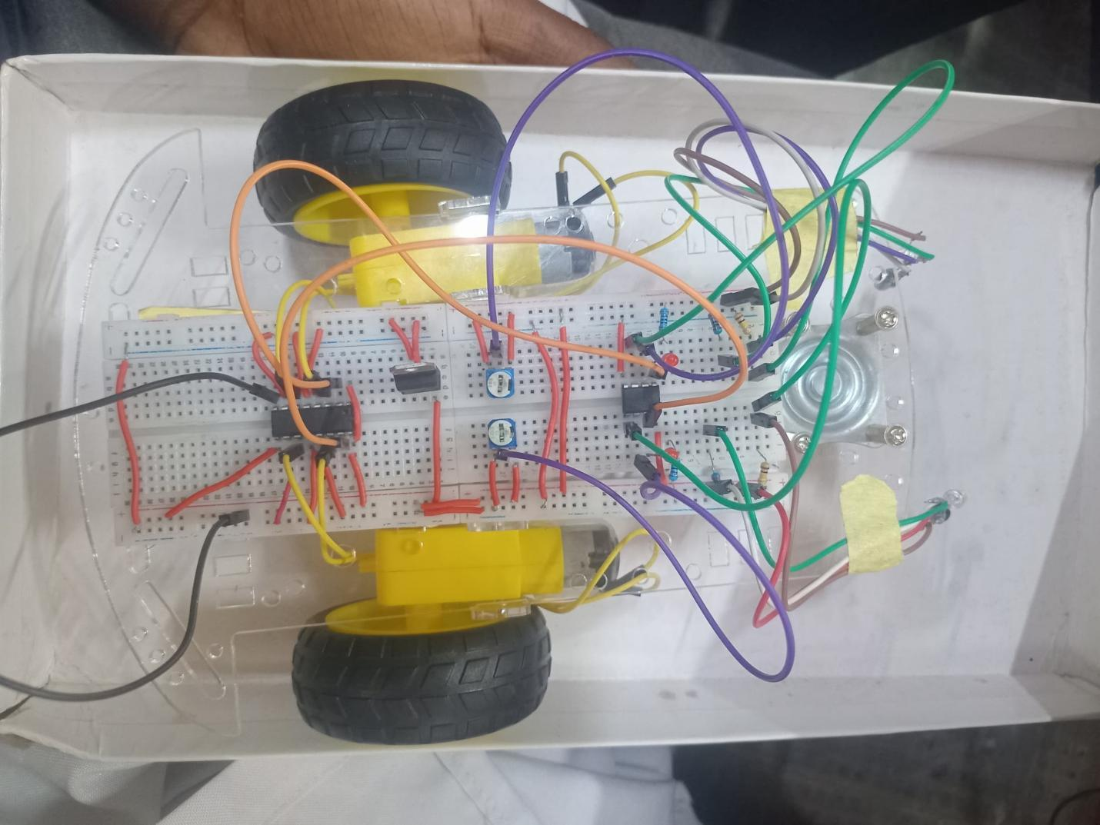

5.3. Challenges and Solutions
- Challenge: Ambient Light Interference. False-positive detections occurred under bright lighting and reflective surfaces from the surrounding.
  - Solution: We recalibrated 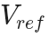 on-site to increase the switching threshold, effectively ignoring lower-level light noise.

Challenge: Track Overshoot. On the 10mm precision line, the robot's speed caused it to occasionally lose the line.
  - Solution: we plan to use a pwm dc motor speed controller module controller or a 555 Timer PWM via L293D Enable Pins

6.0 CONCLUSION AND RECOMMENDATIONS
The project successfully fulfilled all EEG 331 requirements. For future improvements, we recommend integrating a pulse-width modulation (PWM) circuit to provide proportional steering instead of the current discrete ON/OFF switching, which would further increase tracking smoothness.

7.0 BILL OF MATERIALS
Quantity | Component | Description / Function
1 | LM358 IC | Dual Op-Amp (Comparator Logic)
1 | L293D IC | Dual H-Bridge Motor Driver
1 | LM123 | 5V Linear Voltage Regulator (Logic power isolation)
2 | IR Transmitter (LED) | Emits infrared light onto the track surface
2 | IR Receiver (Photodiode) | Detects reflected IR light (Analog optical input)
2 | 10kΩ Potentiometer | RV1, RV2 (Variable resistors for threshold calibration)
2 | 100kΩ Resistor | R3, R4 (Fixed pull-down resistors for sensor dividers)
2 | 1kΩ Resistor | R1, R2 (Current limiting for indicator LEDs)
2 | Red LED | D1, D3 (Real-time logic state visual indicators)
2 | DC Geared Motor | Actuators (e.g., BO motors, 60 RPM)
1 | Analog PWM Module | COTS motor speed controller (To correct motor torque imbalance)
2 | 2 X 3.7V batteries | Main power supply (Wired in parallel for sufficient current capacity)

REFERENCES
- Circuit Digest, “How to Make a Line-Follower Robot Without a Microcontroller,” 2018. [Online]. Available: https://www.circuitdigest.com/article/how-to-make-line-follower-robot-without-using-microcontroller
- Boylestad, R. L. (2012). Electronic Devices and Circuit Theory. Pearson Education.
- Texas Instruments. (2020). LM358 Operational Amplifier Datasheet.

